# 

# **Mediation Analysis**

# 

# 

**Abstract**

In this day and age, organizations seek to expose employees to a variety of work so that they have a higher job satisfaction. By taking Variety of work as an Independent variable and Job Satisfaction as our prediction and thus, our dependent variables, we perform statistical analysis to determine whether there exists a relationship between the two variables. Furthermore, we also take Job Learning as a mediator between Variety of Work and Job Satisfaction. Our assumption is that its not just being exposed to different tasks or departments that increase our job satisfaction but if exposure results in increased learning and growth then that in turn, will increase job satisfaction. As a result, there is another set of statistical analysis performed that determines whether there is a relationship between Variety of Work and Job Learning and whether there’s also a relationship between Job Learning and Job Satisfaction. Our results suggest

**Introduction**

Organizations have recently become more and more aware of the importance of bringing more exposure to the employees when it comes to their nature of work. Employees, themselves, have realized that in order to remain relevant in this technologically evolving society, they need to be well-versed in various roles. This is because the boundaries of every field have become blurry and this has brought about the age of collaboration where people work together to progress. As such, organizations have started taking measures such as the adoption of Management and Graduate Trainee programs which aim to give employees an all-around experience. These efforts can bear positive results for the companies by promising a higher job satisfaction among the employees and therefore, possibly, a higher retention rate.

However, it's also important for companies to realize that a higher job satisfaction may not be achieved by just increasing the variety of work that employees do. Instead, what may also be necessary are the lessons and the processes that they learn through those roles or that work. An employee, specializing in IT, but exposed to Finance as part of his training program may not be satisfied if all he does is run some menial tasks.

Therefore, this study analyzes two separate things. It determines whether the variety of work that an employee does affect his or her job satisfaction. Then, it further analyzes if the amount of learning during a role is the casual basis behind the increasing or decreasing relationship between variety of work and job satisfaction. It may be that work variety leads to an increased growth or more learning which in turn leads to higher job satisfaction.

**Background/Theory**

Job satisfaction is defined as the level of contentment employees feel with their job. While this goes beyond their daily duties to cover satisfaction with team members/managers, for this context we will be restricting job satisfaction as the level of contentment employees feel with the work they do and what they achieve through it.

Variety of Work is defined as the unique experience obtained by an employee after having worked in or with people from departments differing from their area of specialization.

Job Learning is defined as the lessons gained during the tenure in a specific role. This can encompass training organized by the company or solely the insights gained by the employee themselves.

Since, the study is investigating whether the variety of work affects job satisfaction, then the former will be the Independent variable while the latter will be the dependent variable. As such, this will also be our first null hypothesis where we theorize that variety of work does not affect job satisfaction.

*H1: There is no relationship between Variety of Work and Job Satisfaction.*

Our second null hypothesis theorizes that a Variety of work does not affect Job Learning. Since we are working with mediation, we also have a third hypothesis that theorizes that Job Learning does not affect Job Satisfaction.

*H2: There is no relationship between Variety of Work and Job Learning..*

*H3: There is no relationship between Job Learning and Job Satisfaction.*

**Methods**

To understand how variety of work affects job satisfaction and whether job learning mediates between the variety of work and job satisfaction we have used the General Society Survey (GSS) data. The GSS data has been studying the growing complexity of American Society and has been monitoring societal change since 1972. The dataset has 57061 records. Table 1 below shows the summary of the data.

Prior to performing mediation analysis we perform Bootstrap Resampling on the data i.e. draw samples with replacement to estimate the distribution of the data. Around 10000 samples are drawn from the data. We make five different models. In the first model the regression is done without controlling the Job Learning variable. Variety of Work and Job Learning are used to predict Job Satisfaction to see the direct effects. In the second model we use work variety to predict job satisfaction to see the total effect of work variety on job satisfaction. The third model predicts Job Learning using variety of work (‘a’ effect estimates). The fourth model involves predicting Job satisfaction using job learning (‘b’ effect estimates). Finally, in the last model we then perform regression with the mediator controlled (‘ab’ effect estimates). We then formulate conclusions based on how much does the Variety of Work affect Job satisfaction through the mediator and what proportion of the direct effect is unmediated.

Table 1

Means, standard deviations, and correlations with confidence intervals

|  |  |  |  |  |  |
| --- | --- | --- | --- | --- | --- |
| Variable | *M* | *SD* | 1 | 2 | 3 |
|  | | | | | |
| 1. JobLearn | 3.25 | 0.79 |  |  |  |
| 2. WorkVary | 3.29 | 0.70 | .45** |  |  |
|  |  |  | [.43, .47] |  |  |
| 3. JobSat | 3.30 | 0.81 | .22** | .24** |  |
|  |  |  | [.19, .25] | [.21, .27] |  |
|  | | | | | |

*Note.* *M* and *SD* are used to represent mean and standard deviation, respectively. Values in square brackets indicate the 95% confidence interval for each correlation. The confidence interval is a plausible range of population correlations that could have caused the sample correlation (Cumming, 2014). * indicates *p* < .05. ** indicates *p* < .01.

**Results**

The result of the first model with Variety of Work and Job Learning as independent variables and Job satisfaction as the dependent variable shows the direct effect. The effect of Variety of Work on Job satisfaction is 0.2 and the effect of Job Learning on Job Satisfaction is 0.14. Both of the predictors are significant. The p-value of Variety of Work is 0 whereas the p-value of Job learning is 3.2e-186.

In the model which has Variety of Work as independent variable and Job Satisfaction as dependent variable, the total effect of Variety of Work on Job Satisfaction is 0.27 which means an increment of 1 in Variety of work scale would cause 0.27 increment in job satisfaction. The p-value of Variety of work is 0 hence the effect is significant. Based on these above two results we can reject the null hypothesis that there is no relationship between Variety of work and Job Satisfaction. In fact there is a positive relationship between Variety of Work and Job Satisfaction.

Similarly, in the model with Job Learning as independent variable and Variety of Work as dependent variable the effect of Job learning on Job satisfaction is 0.14 and the p-value is 3.18e-186. Hence Job learning is a significant predictor of Job satisfaction. An increment of 1 in Job learning scale would cause 0.14 increment in Job satisfaction.

The effect of Variety of Work on Job learning is 0.5 and the p-value is equal to zero hence Variety of Work is a significant predictor of Job learning. An increment of 1 in Variety of Work scale would cause 0.5 increment in Job Learning. Hence, we can reject the second null hypothesis and we can say that there is a positive relationship between Variety of Work and Job Learning.

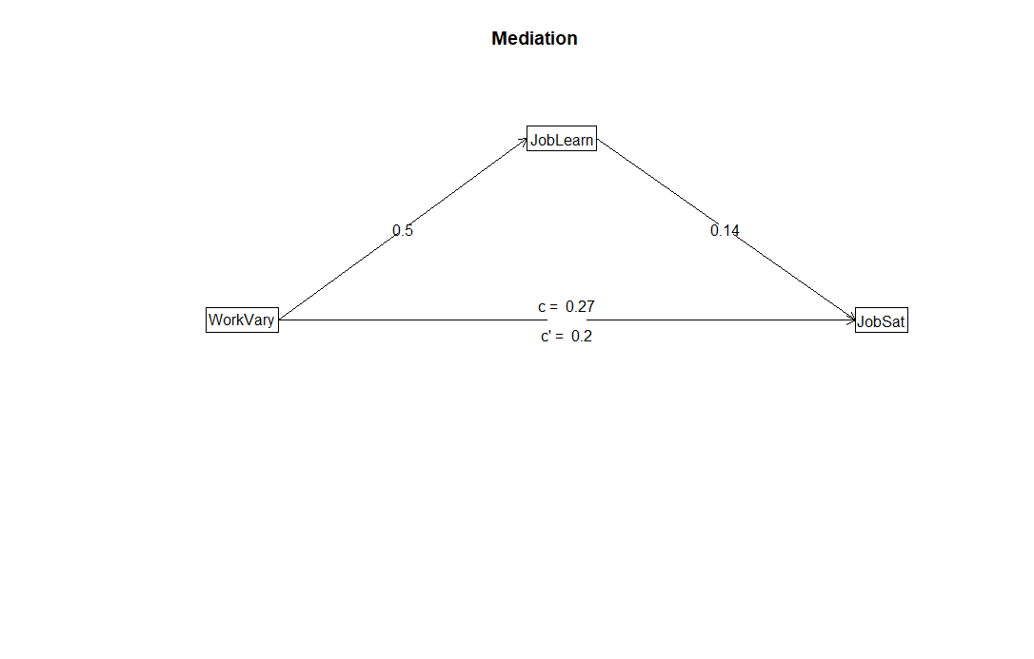

Figure 1. (A) Illustration of a mediation design. Work Variety(WorkVary) is hypothesized to exert an

indirect effect on Job Satisfaction(JobSat) through Job Learning (JobLearn).

The ‘ab’ effect estimate or the effect of Work Variety on Job Satisfaction through Job learning as the mediator is 0.07. In other words with a unit increase in Variety of work Job satisfaction will increase by 0.07. The bootstrap value is 0.07 and the confidence interval is from 0.07 to 0.07. The confidence interval does not include zero hence the bootstrap value is significant. The direct unmediated effect as the proportion of the total effect is 0.2/0.27 or 74% whereas the proportion of the total effect that is mediated is 0.07/0.27 or 26%.

Table 2

Summary of the model results

__________________________________________________________________________________________________________________

|  |
| --- |
| **Full output**  Call: mediate(y = JobSat ~ (JobLearn) + WorkVary, data = GSS.data,  n.iter = 10000  **Direct effect estimates (traditional regression) (c')**  JobSat se t df Prob  Intercept 2.18 0.02 125.89 57058 0.0e+00  WorkVary 0.20 0.01 39.05 57058 0.0e+00  JobLearn 0.14 0.00 29.21 57058 3.2e-186  R = 0.26 R2 = 0.07 F = 2129.71 on 2 and 57058 DF p-value: 0  **Total effect estimates (c)**  JobSat se t df Prob  Intercept 2.40 0.02 151.90 57059 0  WorkVary 0.27 0.00 57.93 57059 0  **'a' effect estimates**  JobLearn se t df Prob  Intercept 1.6 0.01 112.86 57059 0  WorkVary 0.5 0.00 119.92 57059 0  **'b' effect estimates**  JobSat se t df Prob  JobLearn 0.14 0 29.21 57059 3.18e-186  **'ab' effect estimates (through mediators)**  JobSat boot sd lower upper  WorkVary 0.07 0.07 0 0.07 0.07 |
|
|
|
|
|

**Discussion**

From the results above it can be observed that the model has significant mediation since the ‘ab’ effect is greater than 0. Furthermore, the mediation is not full mediation since the direct effect of Variety of Work on Job Satisfaction is significant and the proportion of effect that remains unmediated is 74% which is significantly large.

It means that Job learning to an extent mediates the relationship between Variety of Work and Job Satisfaction there might be some other factors also involved such as complexity of work or number of hours spent working. It might be the case that the work is very complex and it might contribute to learning but it leads to difficulty in delivering results in job or might become a hindrance in performing up to expectation which may impact job satisfaction. If the employee is working more than the required number of hours because of the variety and excessive amount of work then in that case it may almost impact job satisfaction.

Based on the above analysis we can say that first of all there is a relationship between variety of work and job satisfaction, secondly there is also a relationship between job learning and job satisfaction and finally job learning does indeed mediate the relationship between variety of work and job satisfaction.

**Bibliography**

* *General Social Survey (GSS) | NORC.org. Norc.org. Retrieved 23 August 2020, from* [*https://www.norc.org/Research/Projects/Pages/general-social-survey.aspx*](https://www.norc.org/Research/Projects/Pages/general-social-survey.aspx)*.*
* *Verhofstadt, Emy. (2003). The impact of education on job satisfaction in the first job*
* *Hassan Ayub. (2018). The effect of training on job satisfaction.*

**Appendix**

# GSS Data

The General Society Survey (GSS) has been studying the growing complexity of American Society and has been monitoring societal change since 1972. The aim of GSS is to gather data on contemporary American society in order to monitor and explain changes and constants in behaviors, attitudes and other attributes; to examine the functioning and structure of the society as well as understand the role different relevant subgroups play. The GSS aims to gather data on contemporary American society in order to monitor and explain trends and constants in attitudes, behaviors, and attributes; to examine the structure and functioning of society in general as well as the role played by relevant subgroups and to make high-quality data easily available for students, scholars, policy makers and others. The GSS includes questions like national spending priorities, crime, marijuana use and punishment, race relations, quality of life, confidence in institutions and so on and so forth. ("General Social Survey (GSS) | NORC.org", n.d.)

Code:

#install packages

install.packages('psych')

install.packages('apaTables')

#adding packages

library(psych)

library(apaTables)

# mediation

source('GSS-CleanData.R')

mydata <- GSS.data[,c('JobLearn','WorkVary','JobSat')]

#number of rows

nrow(mydata)

#Table 1

apa.cor.table(mydata, filename="table1.doc")

#With 5000 bootstrapping samples

print(mediate(JobSat~ (JobLearn) + WorkVary, data = GSS.data, n.iter = 10000), short = FALSE)

#proportion of mediation

100*(0.2/0.27) #direct unmediated effect as a proportion of the total

(0.07/0.27)*100 #proportion of total effect that is mediated